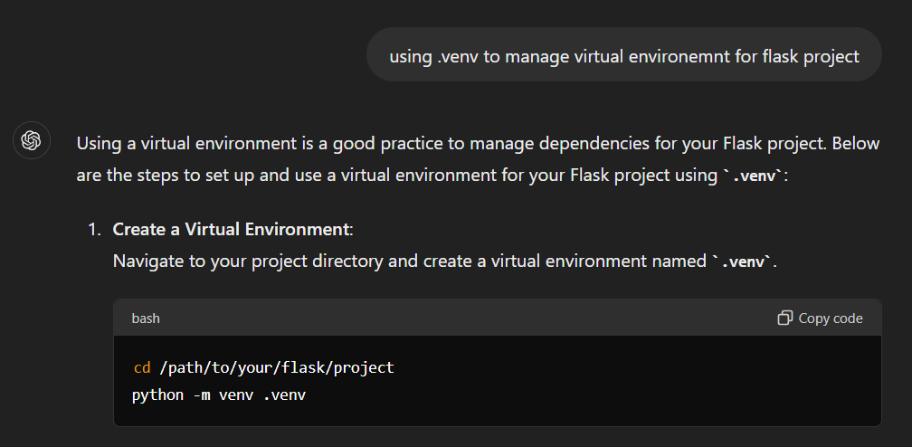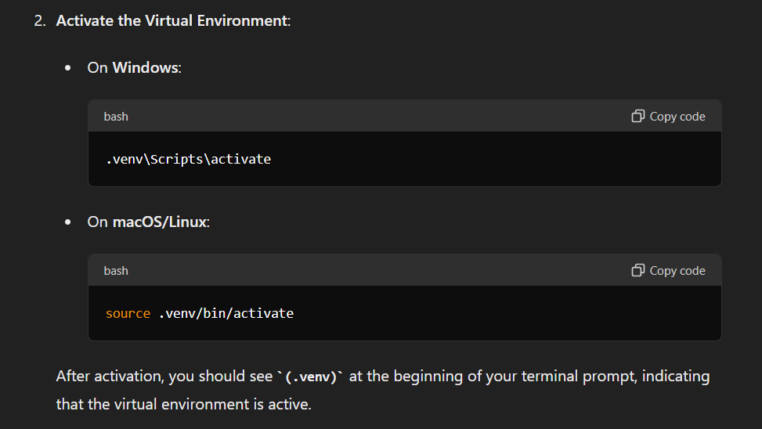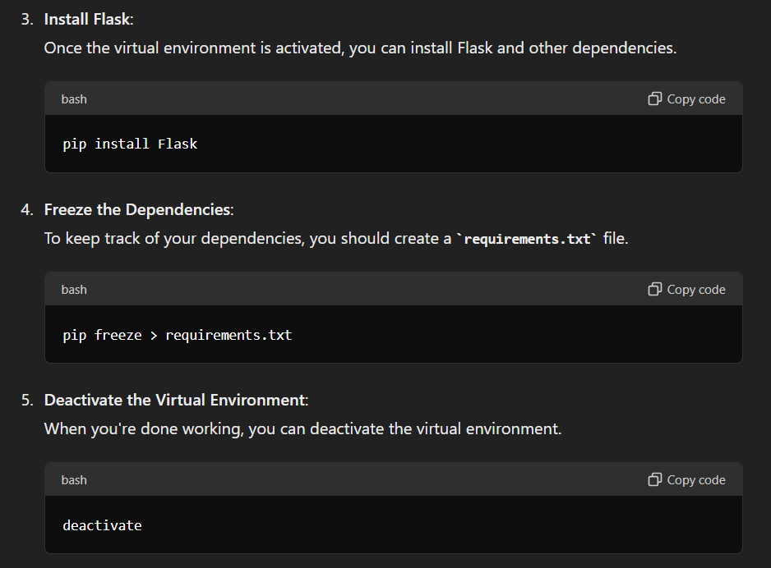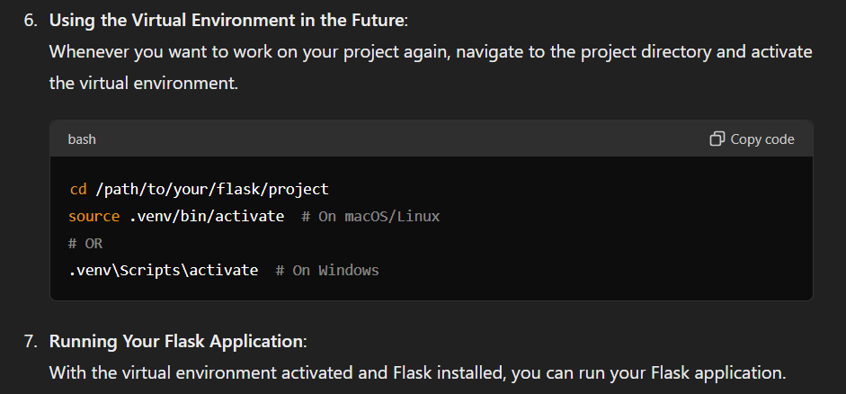

To run the Flask App in the Virtual Environment follow the steps below:

* pip install dotenv
* Create a file called *.env* (Yes it starts with a dot and then the word env for environment)
* In *.env* write:

FLASK_APP=index.py

Since, in index.py we have imported app from wsgi. More on vercel setup in the Vercel Setup note.

